1. Design NFA using simulator to accept the input string “bbc” ,”c”,and ”bcaaa”

*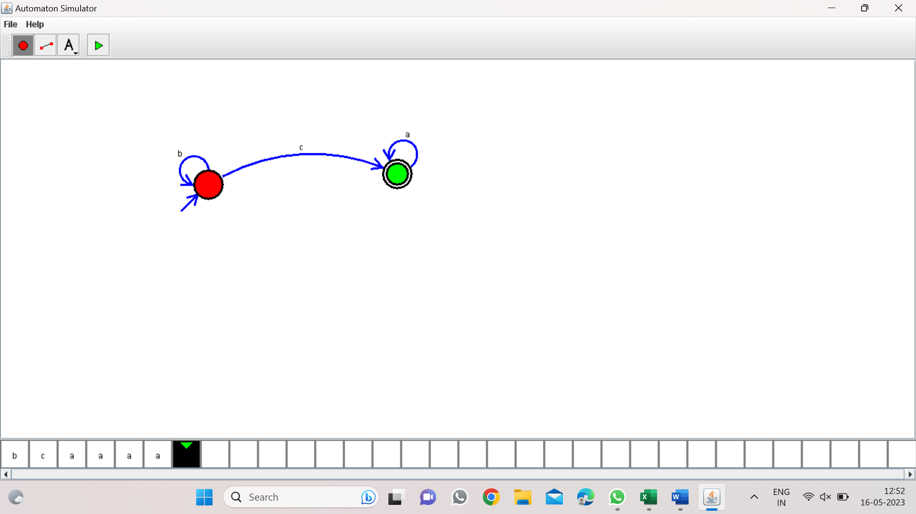*

*Result:-*

*From the above NFA diagram valid the strings “bbc”,”c”,”bcaaa”*